## 4.3 Community

|  |  |  |
| --- | --- | --- |
| Use case name: | **Community** | |
| Scenario: | A more convenient way for members to show case their skills and get extra income | |
| Triggering event | A member is looking for another YMCA member with certain skills. | |
| Brief description | A member can search through the YMCA search section to find member who have certain skills and willing to get an extra income. | |
| Actors | Member | |
| Related use cases | Branch, Programme , Member and Payment | |
| Preconditions | None | |
| Post conditions | System must be able to show members who fit the job description. | |
| Flow of Activities | Actor | System |
| 1. Member clicks to search and find members around the same YMCA branch who fit a certain description.  2. Member selects the right candidate for the job. | 1.2 System appropriate members only.  2.1 System captures and saves |
| Exception condition | 1.1Member job description is invalid. | |

## 4.4 Enquiries

|  |  |  |
| --- | --- | --- |
| Use case name: | **Enquiries** | |
| Scenario: | A convenient way for a member to get help with a query or problem. | |
| Triggering event | A member is experiencing technical or any other difficulties within the web application. | |
| Brief description | A member will be able to get step by step instructions that will be sent by the admin for each category in the web application. | |
| Actors | Member , Admin | |
| Related use cases | None | |
| Preconditions | Member must be able to log in with correct credentials. | |
| Post conditions | Member must be able to send help token to admin. | |
| Flow of Activities | Actor | System |
| 1. Member logs in with credentials.  2. Member encounters problem/query in the web application.  3. Member clicks help desk button. | 1.2 Verify credentials.  3.1System allows member to send help token to admin. |
| Exception condition | 1.1Member credentials are incomplete or incorrect.  2.1System fails to allow member to send help token | |

## 4.5 Cart Management

|  |  |  |
| --- | --- | --- |
| Use case name: | **Cart Management** | |
| Scenario: | A more convenient way for members to shop for YMCA items. | |
| Triggering event | A member wants to purchase items. | |
| Brief description | A member will be able to purchase certain YMCA items on the web application | |
| Actors | Member , Admin | |
| Related use cases | None | |
| Preconditions | Member must be able to log in with correct credentials.  Admin must be able to log on with correct credentials. | |
| Post conditions | Member must be able to view items and add quantity to cart. | |
| Flow of Activities | Actor | System |
| 1. Member logs in with credentials.  2. Member selects item of choice to purchase and quantity.  4. Member Attaches proof of payment.  5. Admin selects that item has been sent for collection. | 1.2 Validates credentials.  2.1 System adds items to cart.  2.2 system saves member details.  3. System sends email of banking details to the member |
| Exception condition | 1.1Member credentials are incomplete or incorrect. | |

## 4.6 Manage Report

|  |  |  |
| --- | --- | --- |
| Use case name: | Manage Reports | |
| Scenario: | Generate online report that can be downloaded or emailed. | |
| Triggering event | A member wants to view a report for either events, budget or donation. | |
| Brief description | There will be a dashboard for the admin to view the reports for budgets, event, and donations. | |
| Actors | Admin , member | |
| Related use cases | Event, Payment, donations | |
| Preconditions | Member must be logged on. | |
| Post conditions | Report must be generated ,downloaded or emailed depending on what the member would like to do | |
| Flow of Activities | Actor | System |
| 1. Member requests report.  2. Member confirms report details.  3.Member wants to email the report | 1.1 Verify credentials  2.1 Confirm and display updated information  3.1System validates  3.2System allows member to send email |
| Exception condition | 1.1Email details are incomplete or incorrect. | |

## Extra features

* **Event gallery**

Event Organizer member has authorization to upload photos for past events, this will send an email to all members in the programme, to notify that they have been uploaded. Photos can be added as many times, and every time they are uploaded the members are emailed again. Programme members can go and view the photo gallery, and save photos if desired.

* **Assigning roles**

Assigning roles for committee members, the roles are:

* Head of committee
* Vice head of committee
* Treasurer
* Secretary

When an event is created, the head of committee assigns a team to organize the event for the team, team leader, budget handler and photographer. An email will be sent to each member in the event organizer team. There will be an attendance tracker for the team

# 5. Mobile App

## 5.1 Member Subscription

|  |  |  |
| --- | --- | --- |
| Use case name: | **Member subscription** | |
| Scenario: | User applying to become a YMCA member | |
| Triggering event | User want to know more about YMCA. | |
| Brief description | A User will be able to apply to become a member. When their application has been approved, they will receive an email with a password to use when accessing the system. | |
| Actors | User | |
| Related use cases | Event management | |
| Preconditions | none | |
| Postconditions | Should receive feedback for the application | |
| Flow of Activities | Actor | System |
| 1. Enter user details.  2. Confirms. | 1.1 Validate user details.  2.1 Display and save. |
| Exception condition | 1.User omits or enters invalid data | |

## 5.2 Manage Event

|  |  |  |
| --- | --- | --- |
| Use case name: | **Event management** | |
| Scenario: | Scheduling an event for members. | |
| Triggering event | Staffs needs to schedule an event for programs. | |
| Brief description | A staff schedules an event for a program by entering event details | |
| Actors | Staff | |
| Related use cases | Programs | |
| Preconditions | Member must be logged on | |
| Post conditions | Member must receive email about the event | |
| Flow of Activities | Actor | System |
| 1. Enter event details.  2. Confirms.  3.Rate event  4. Scan barcode to be on the attendee list | 1.1Display event details.  2.1Display event on calendar. |
| Exception condition | 1.1login details are incorrect.  1.2Event can be cancelled in case on weather. | |

## Extra Features

The Mobile App will have other features that include:

* Being able to access the YMCA Facebook page
* Memo for writing notes on the app
* Chatbot
* Checking weather forecast

# 5. ERD reduced to 3rd NF

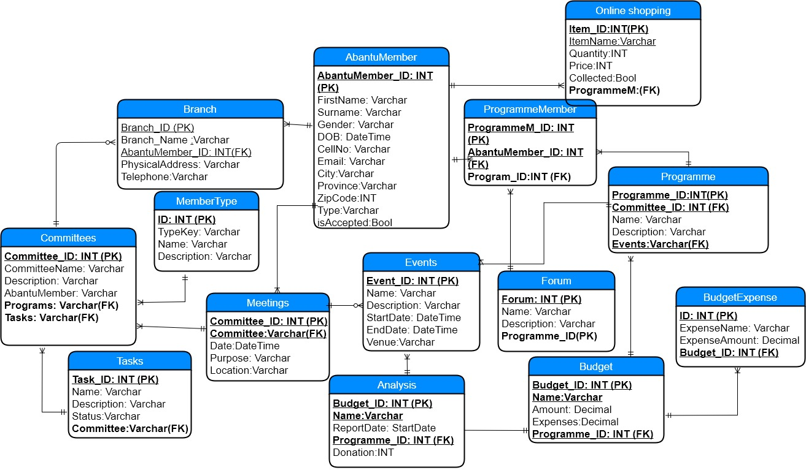

# Class diagram

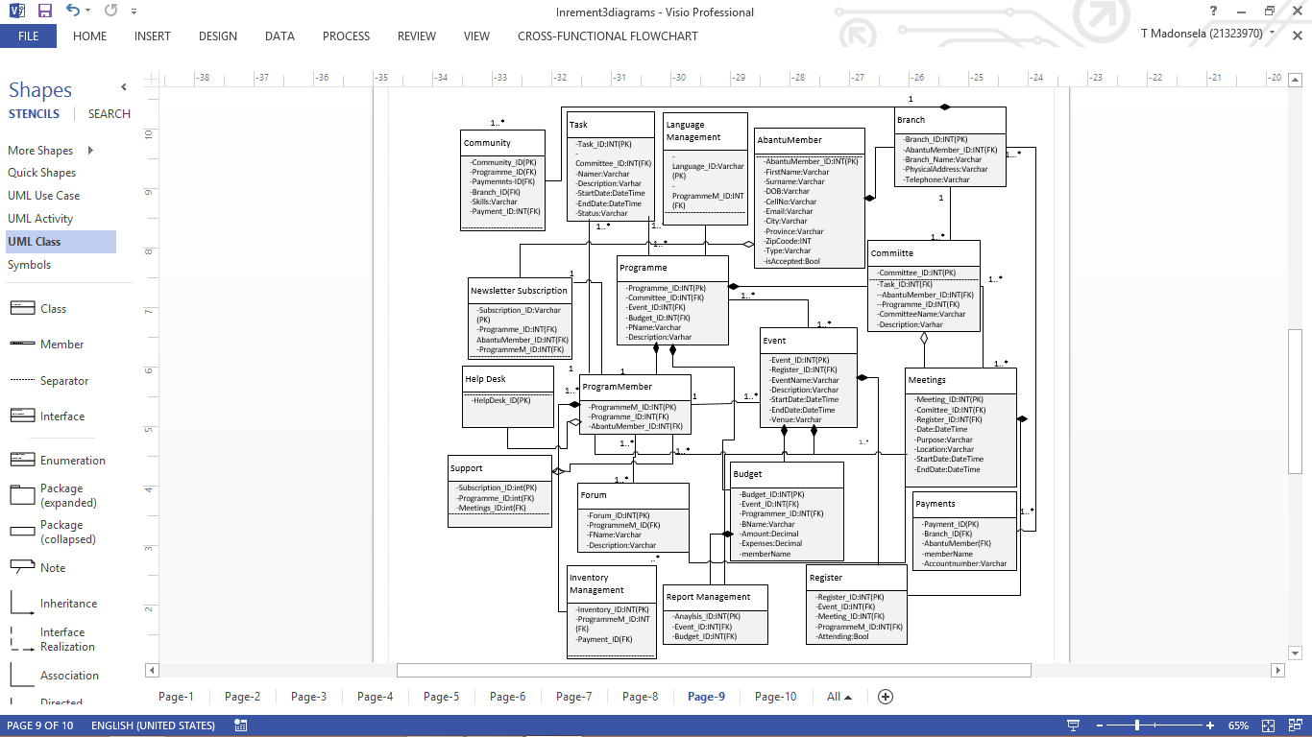

# Gantt chart

# Kanban Chart

# Test plan (Optional)

|  |  |  |  |  |  |  |  |
| --- | --- | --- | --- | --- | --- | --- | --- |
| **Test Case No** | **Use case Name** | **Scenarios** | **Step - Name/#** | **Step - Description** | **Step - Expected Result** | **Actual** | **Status - Pass / Fail** |
| **1** | Enquiries | **Test Objective: Generate and view Helpdesk tickets and provide support** **Pre-condition:** A failure or inquiry must be presented Post-condition: A ticket has been sent or viewed accordingly Actors:  Admin, Non-member, Member | Step 1 | Redirect to the Helpdesk view, available to all personnel. Create an appropriate ticket according to your inquiry. Upon completion the ticket is added to the list of tickets, if files or comments have been included they will be added to the comments and files list with a direct relation. The admin will once logged in can view a list of tickets, view and provide support as sufficient as possible. The admin can view and download the files included with the ticket. | Ticket Creation Successful, ticket files upload successful, ticket viewing successful, ticket response successful | Ticket Creation Successful, ticket files upload successful, ticket viewing successful, ticket response successful | Pass |

|  |  |  |  |  |  |  |  |  |  |  |  |  |  |  |
| --- | --- | --- | --- | --- | --- | --- | --- | --- | --- | --- | --- | --- | --- | --- |
| **Test Case No** | **Use case Name** | | **Scenarios** | | **Step - Name/#** | | **Step - Description** | | **Step - Expected Result** | | **Actual** | | **Status - Pass / Fail** | |
| **1** | Add to Store | | **Test Objective: Add new item to store** **Pre-condition:** Admin must exist Post-condition: **Item is added to store**  Actors:  Admin System | | Step 1 | | Click button to add to store | | Added to store | | Nothing Happened | | Fail | |
| **2** | Add to Store | | **Test Objective: Add new item to store** **Pre-condition:** Admin must exist Post-condition: **Item is added to store**  Actors:  Admin System | | Step 1 | | Click button to add to store | | Added to store | | Item added to store | | Pass | |
| **3** | Add to Cart | | **Test Objective: Ensure the cart is working and everything is added**  **Pre-condition: Store must have items to purchase** Post-condition: **Items are added to the cart with totals**  Actors:  User | | Step 1  Step 2 | | Click add to cart on required item Check if added to cart | | Added to cart successfully | | Added to cart successfully, with the relevant prices and totals | | Pass | |
| **Test Case No** | | **Use case Name** | | **Scenarios** | | **Step - Name/#** | | **Step - Description** | | **Step - Expected Result** | | **Actual** | | **Status - Pass / Fail** | |
| **1** | | Create Report | | **Test Objective: Allow the admin user to request a report**  **Pre-condition:** User must exist, Budget Must exist Post-condition: **Admin is allowed to view the report**  Actors:  Admin System | | Step 1 | | Request Report by clicking button | | Request Unsuccessful | | Nothing Happened | | Fail | |
| **2** | | Create Report | | **Test Objective: Allow the admin user to request a report**  **Pre-condition:** User must exist, Budget Must exist Post-condition: **Admin is allowed to view the report**  Actors:  Admin System | | Step 1 | | Request Report by clicking button | | Request Successful | | Admin is re-directed to view the report, it has navigation properties | | Pass | |
| **2** | | Show Expenses on Report | | **Test Objective: To ensure all relevant info is on the report**  **Pre-condition: Budget must have an amount, and expenses** Post-condition: **Report is displayed with the relevant information**  Actors:  User | | Step 1  Step 2 | | Request Report by clicking button Open Report to analyse | | Report is correct format | | Admin can view the report being correct with all the relevant information | | Pass | |

|  |  |  |  |  |  |  |
| --- | --- | --- | --- | --- | --- | --- |
| **Use case Name** | **Scenarios** | **Step - Name/#** | **Step - Description** | **Step - Expected Result** | **Actual** | **Status - Pass / Fail** |
| Promotion | **Test Objective: Allow a valid member to upload YMCA accommodation in the system** **Pre-condition: Accommodation** must exist in the YMCA. Post-condition: **Member has access to the accommodation**  Actors:  Admin, Member | Step 1 | A staff or member wants to promote an accommodation. | The System Successfully advertised the accommodation | Accommodation advertised | Pass |
| Promotion | **Test Objective: Deny an invalid accommodation**  **Pre-condition: Accommodation** must not exist Post-condition: Incorrect accommodation   Actors:  Admin, Member | Step 1 | An invalid member wants to advertised an accommodation | Accommodation not advertised | The system denies advertisement | Fail |

|  |  |  |  |  |  |  |
| --- | --- | --- | --- | --- | --- | --- |
| **Test Case No** | **Use case Name** | **Scenarios** | **Step - Name/#** | **Step - Description** | **Step - Expected Result** | **Status - Pass / Fail** |
| **1** | Services | **Test Objective: Allow for viewing members with certain skills.**  **Pre-condition:** Member must exist Post-condition: **Member has updated their profile**  Actors:  Admin,User  Notes: Anyone can view services they can get from other members within the system. | Service lookup | Choose a particular service you might like to get | Shows list of members who can offer that service. | Pass |
| **2** | Services | **Test Objective: Do not show member's skills**  **Pre-condition: User must not have updated their profile** Post-condition: Shows no member  Actors:  Admin,User  Notes: If a member did not update the profile adding skills they will not show up under Services | Service lookup | Choose a particular service that no member has added on their profile. | Shows no member | Fail |

Abantu Member Management

**Minutes of general meeting**

Date: 28 August 2017

Time: 12:00 – 13:00 Venue: DS LAB

Welcome: Chad welcomed all present.

Attendance: C.Venter (Group Leader)

N.Bohlela

T.Madonsela

W.Pillay

C.Zuma

D.Fisher

L.Nsindane (Secretary)

Apologies: None

Discussions

1. As a group we reviewed all the suggestions made by the examiners and worked on

Implementing the suggestions.

Date of next meeting

4 September 2017

__________________ ___________________

Secretary Group Leader

Abantu Member Management

**Minutes of general meeting**

Date: 04 September 2017

Time: 12:00 – 13:00 Venue: Mr. Charles Office

Welcome: Mr. Charles welcomed all present.

Attendance: C.Venter (Group Leader)

N.Bohlela

T.Madonsela

W.Pillay

C.Zuma

D.Fisher

L.Nsindane (Secretary)

Apologies: None

Discussions

1. The group made suggestions on which use cases we could implement for increment.

2. Chad divide the roles for each person.

Date of next meeting

11 September 2017

__________________ ___________________

Secretary Group Leader

Abantu Member Management

**Minutes of general meeting**

Date: 11 September 2017

Time: 12:00 – 13:00 Venue: Mr. Charles Office

Welcome: Mr. Charles welcomed all present.

Attendance: C.Venter (Group Leader)

N.Bohlela

T.Madonsela

W.Pillay

C.Zuma

D.Fisher

L.Nsindane (Secretary)

Apologies: None

Discussions

1. The group discussed further on increment 4 use cases and to show system functionality on the next meeting.
2. Mr. Charles suggested we keep our original menu throughout the system to make it easier for the user to navigate.
3. Dylan presented his use case and sir made some suggests.
4. Mr. Charles suggested we add more use cases for increment 4 as the ones we have are not enough.

Date of next meeting

18 September 2017

__________________ ___________________

Secretary Group Leader

Abantu Member Management

**Minutes of general meeting**

Date: 18 September 2017

Time: 12:00 – 13:00 Venue: Mr. Charles Office

Welcome: Mr. Charles welcomed all present.

Attendance: C. Venter (Group Leader)

N. Bohlela

T.Madonsela

W. Pillay

C.Zuma

D.Fisher

L.Nsindane (Secretary)

Apologies: None

Discussions

1. Sir explained how each business process should be structured using a different example.

Date of next meeting

25 September 2017

__________________ ___________________

Secretary Group Leader